Creating a “simple timeline” and “tabular timeline” in Excel.

Step 1. Create a spreadsheet with the column headings detailed below. Click on ‘Freeze Top Row’ icon, which is an option in the ‘View’ menu. This means that the column headings can be seen as you scroll down the page.

Step 2. It is also useful to format the event and details column to ‘wrap text’ so you can fit everything in. ‘Auto fit column width’ can also help if you are having difficulty fitting in lots of text into the ‘Details’ column.

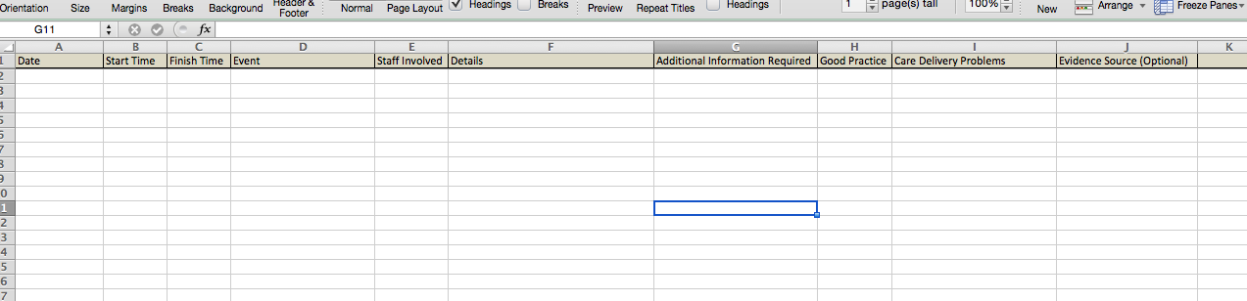

Step 3. Enter information for the particular piece of evidence you are looking at to populate your simple timeline – see below.

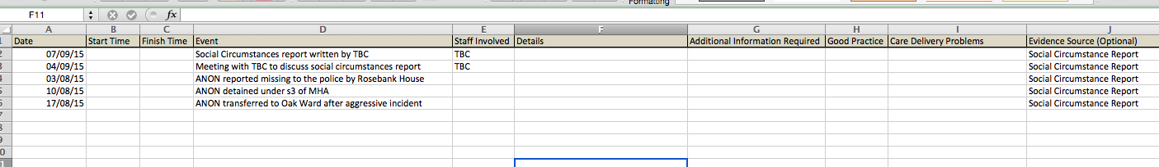

Step 4. Enter information from another piece of evidence, and so on.

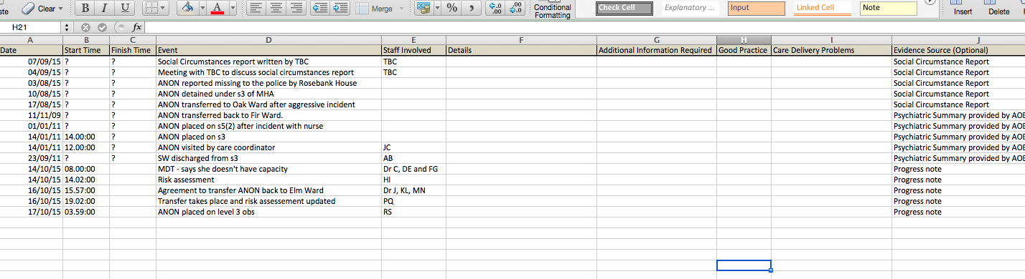

Step 5. Once you have entered all the information you currently have (for the simple timeline) you need to sort it into chronological order.

Step 6. Highlight all of the information in the sheet by pressing the arrow in the top left corner. All of the sheet will turn blue.

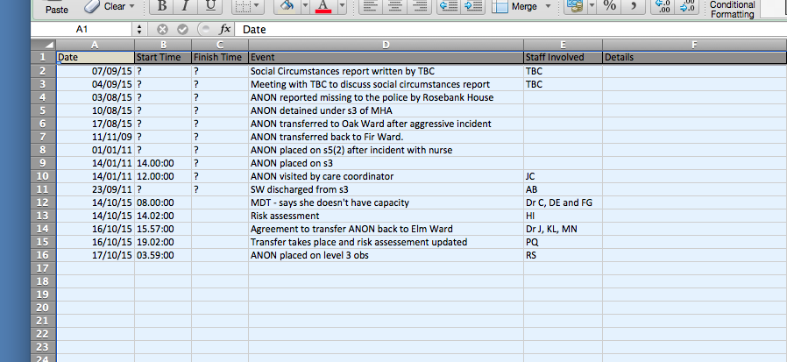

Step 7. Go to the data menu.

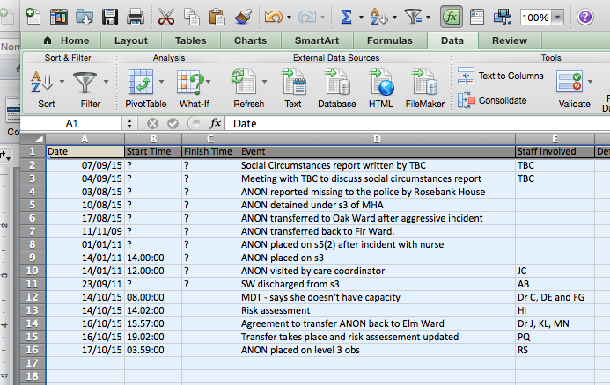

Step 8. Press on the ‘sort’ button and a drop down menu will appear.

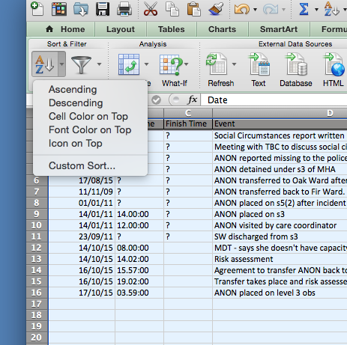

Step 9. Select custom sort from the drop down menu. You will see the following box.

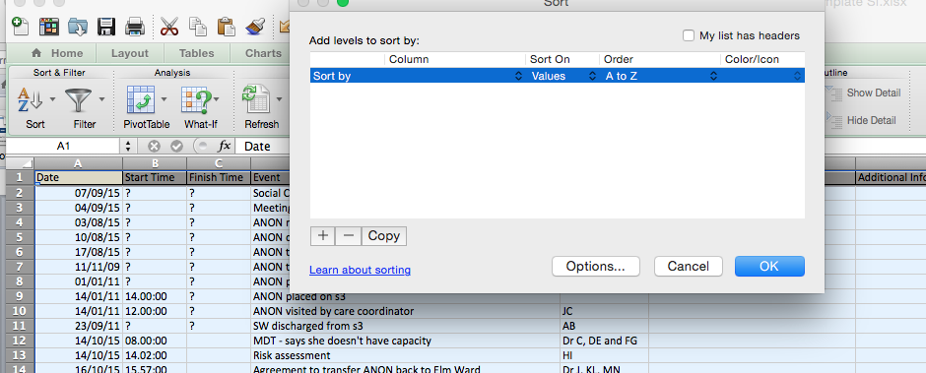

Step 10. Click below the ‘column’ on the two small up and down arrows and a menu will appear. Click on Date or Column A.

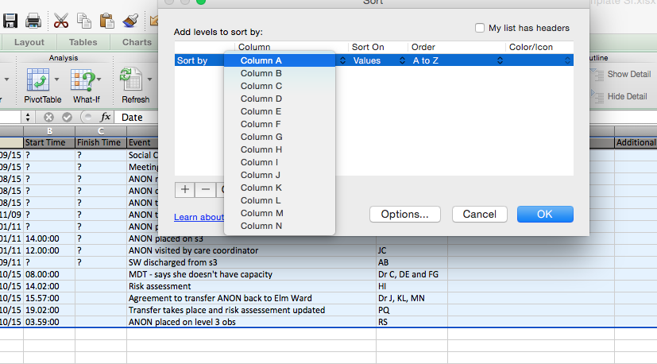

Step 11. The click on the plus sign in the bottom left of the box.

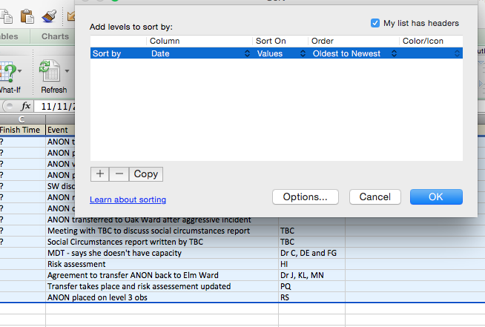

Step 12. Clicking on the arrow will bring up another line entitled ‘Then by’ – click on the small up and down arrows under the ‘column’ heading for this line and another drop down menu will appear. This time select ‘Column B’ or start time. Then click ok. Tick the box in the top right hand corner to stop the headers for your columns being ‘sorted’.

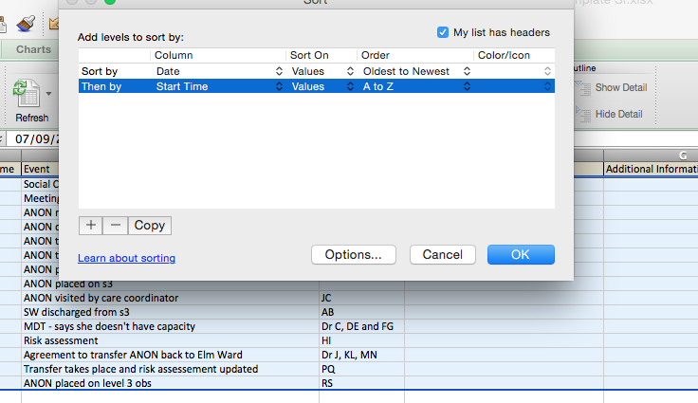

Step 13. Your timeline should now be in date and time order.

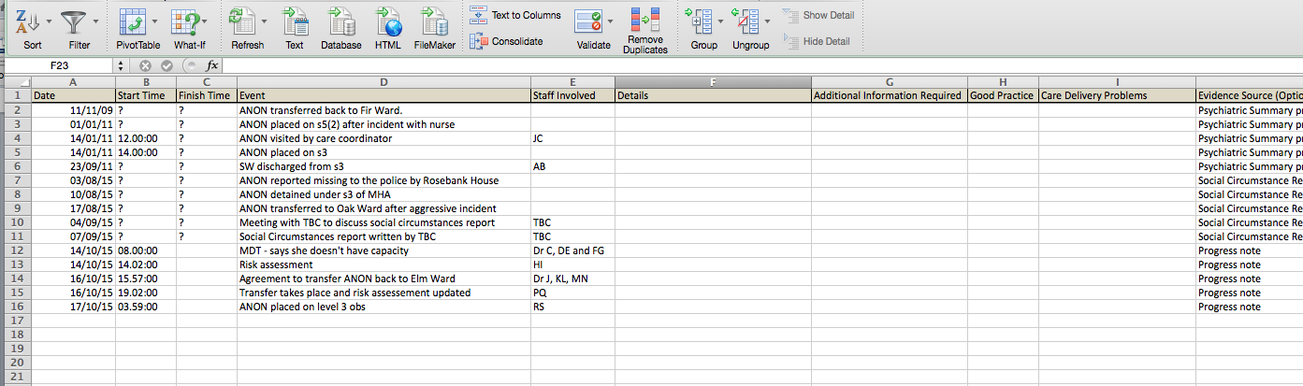

Step 14. You can now add additional new information to the bottom rows of the spreadsheet, run the process outlined above again, and the new information will be incorporated into your timeline.

Step 15. To create a tabular timeline you simply move on to filling in the details section, additional information required and identify your care delivery problems in the normal way.

